**Results**

**Spatial Variation in Diesel Ownership**

Figure Y displays the rate of diesel car ownership across the local authorities of the UK grouped by Government Office Region. From this figure, it is apparent that the local authorities of Northern Ireland tend to contain higher proportions of diesel cars in their fleets compared to other regions. This observation indicates that a factor is active in Northern Ireland that may be encouraging the ownership of diesel cars which is not present in the rest of the UK.

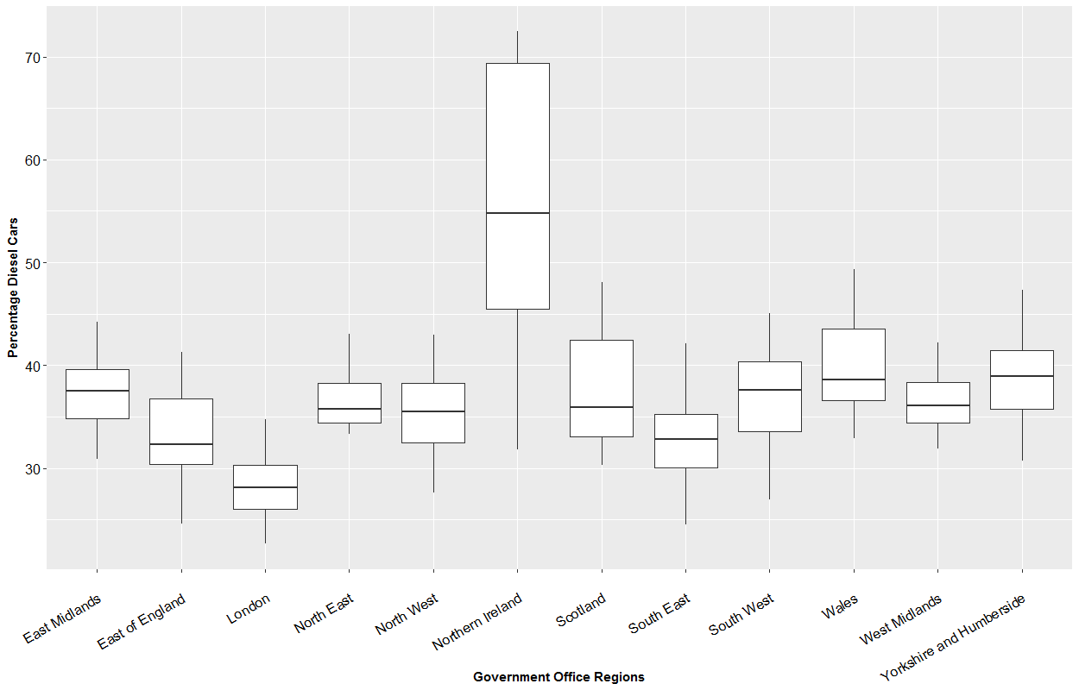

**Figure Y:** The percentage of local authority car fleets that are fuelled by diesel grouped by Government Office Region

Examining the spatial variation in diesel car ownership that is present within Northern Ireland, Figure Y illustrates the percentage of the car fleet which is diesel fuelled across the SOAs. In this figure, it is evident that spatial units that are closer to the border with the Republic of Ireland tend to display higher rates of diesel car ownership, with the rate diminishing as proximity to Belfast (the national capital located in the mid-east) increases.

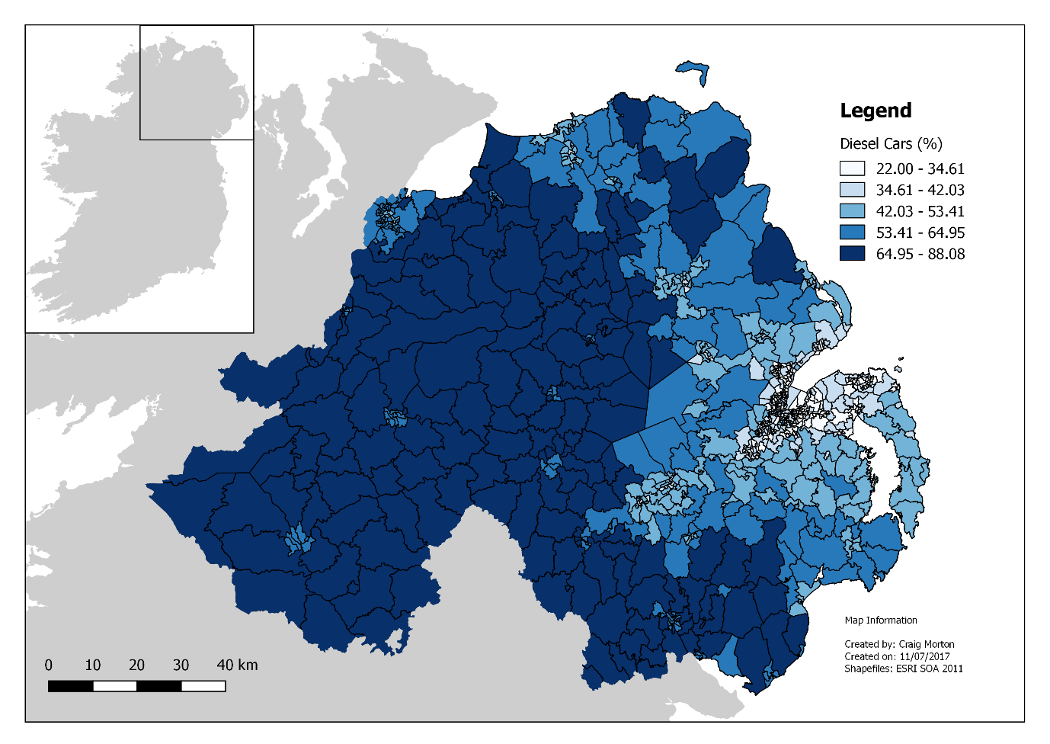

**Figure Y:** Choropleth map showing the proportion of the local car fleet that is diesel fuelled across the Super Output Areas of Northern Ireland

The spatial patterning in the rate of diesel car ownership also exhibits signs of spatial dependence, whereby the proportion of the car fleet which is diesel fuelled in one spatial unit tends to be related to the proportion observed in neighbouring spatial units. This is supported by Moran’s-I test of spatial autocorrelation, which returns a strong positive coefficient (*I* = 0.919, p-value < .001). The occurrence of spatial dependence is clearly visible in the LISA analysis reported in Figure Y. Here, it is apparent that the border region of Northern Ireland, and extending a considerable distance inland, represents a hot-spot of diesel car ownership. Conversely, a cold-spot is present in the mid-east of the country and corresponds with the metropolitan area of Belfast.

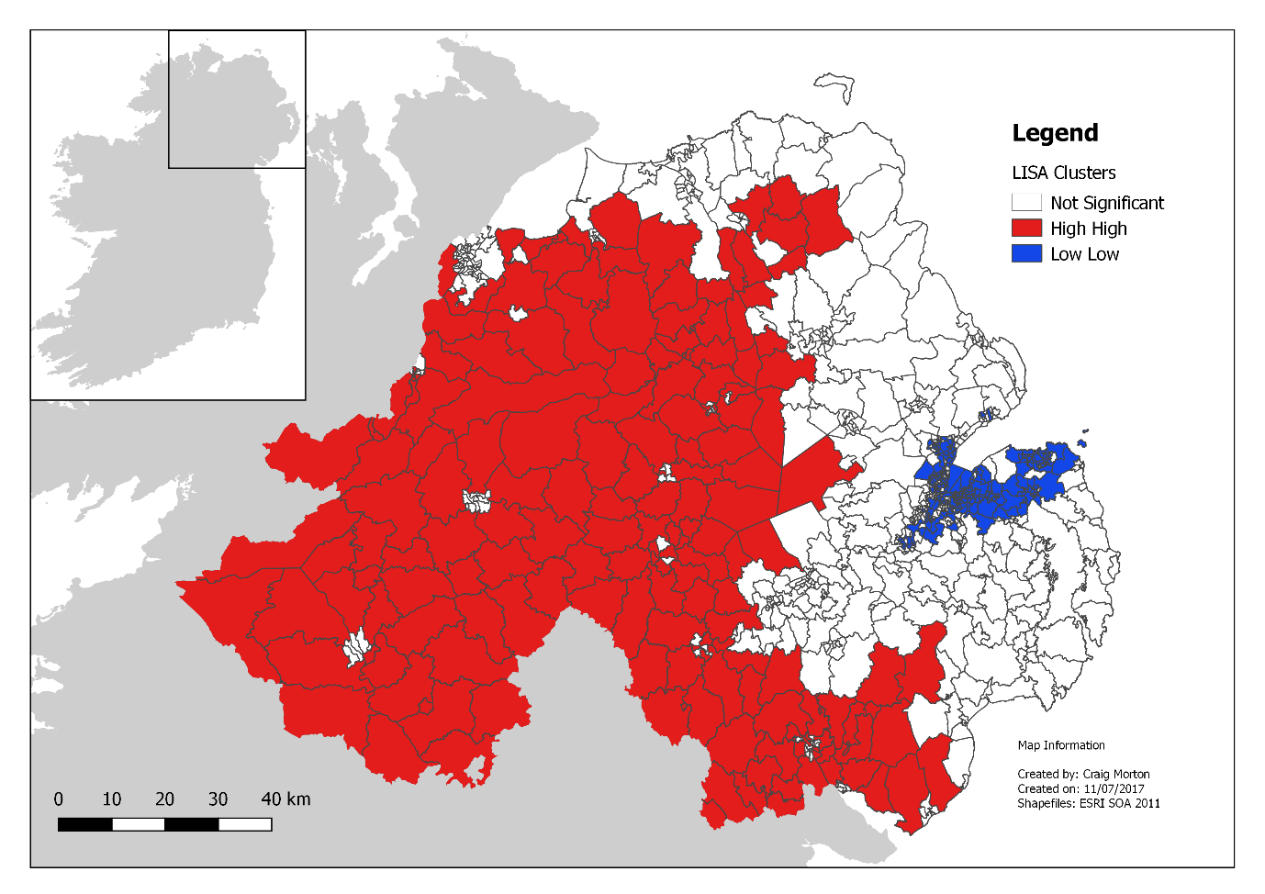

**Figure Y**: Local indicator of spatial association concerning the proportion of the local car fleet which is diesel fuelled

**Nearness to the Republic of Ireland**

Figure Y displays the dispersion of the local car fleet that is fuelled by diesel across the border buffer groups of SOAs (i.e. the contiguity method). SOAs that intersect both a 5, 10, 15, and 20 km buffer with the border to the Republic of Ireland appear to have similar rates of diesel car ownership. This rate decreases noticeably for the SOAs that are outside of a 20 km buffer to the border (i.e. the rest of Northern Ireland), where the average rate of diesel car ownership is approximately 40%. The visible difference between the SOAs of the rest of Northern Ireland category and those assigned the buffer categories is supported by a significant Kruskal-Wallis test result (H = 335.929, p-value < .001).

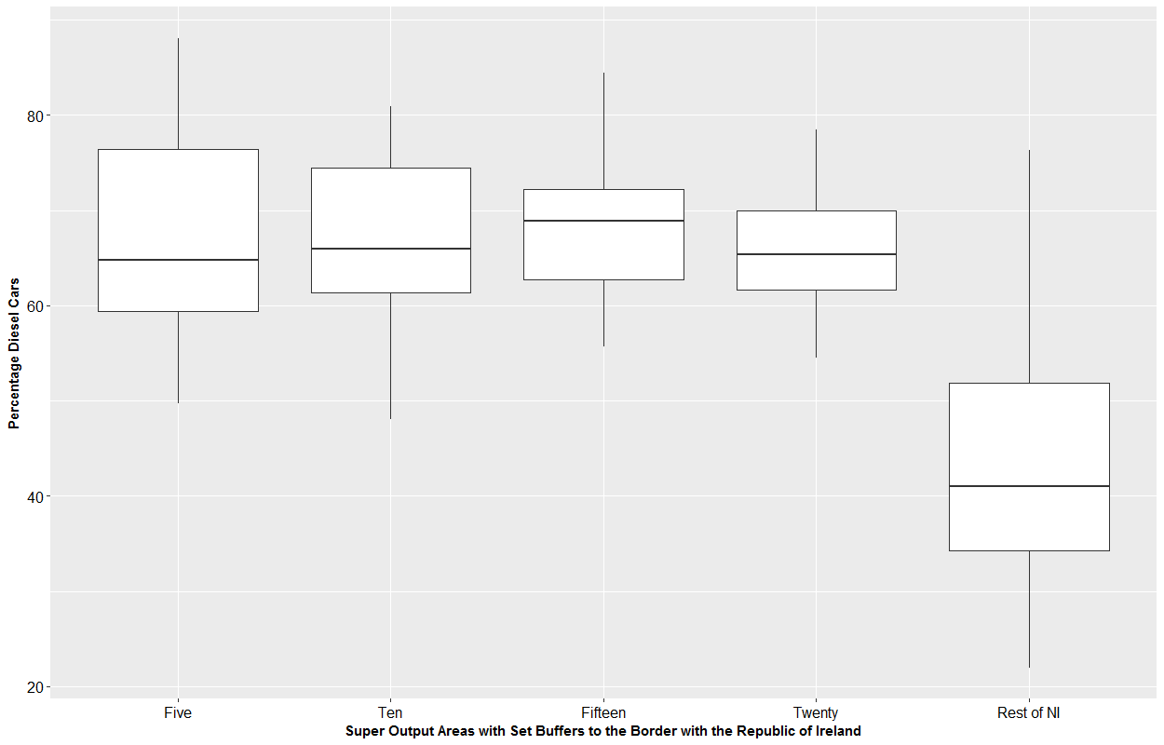

**Figure Y**: Boxplots grouping Super Output Areas by buffer to the border with the Republic of Ireland (i.e. the contiguity method) by the proportion of the car fleet that is fuelled by diesel

Figure Ya evaluates the relationship between diesel car ownership and Euclidean distance to the nearest road crossing into the Republic of Ireland (i.e. the proximity method). In this instance, a negative relationship is evident (rs: -0.713, p-value < 0.001), implying that as proximity to the border decreases, the rate of diesel car ownership tends to decrease. A similar set of findings is presented when considering network distance to the nearest fuel station in the Republic of Ireland (Figure Yb; rs: -0.598, p-value < 0.001) and network time to the nearest fuel station (Figure Yc, rs: -0.475, p-value < 0.001).

|  |  |  |
| --- | --- | --- |
|  |  |  |

**Figure Y:** Scatterplots of proportion of the Super Output Area car fleet that is diesel fuelled (y-axis) against (a) Euclidean distance to the nearest road crossing, (b) network distance to the nearest fuel station in the Republic of Ireland, and (c) network time to the nearest fuel station in the Republic of Ireland

**Regression Analysis**

The benchmark log-log OLS regression models, which have the proportion of the car stock which is diesel fuelled as the dependent variable, are reported in Table Y. The inclusion of measurements of nearness to the Republic of Ireland (OLS Models 2 to 4) provide significant improvements to model fit as compared to the base model (OLS Model 1) which only considers the effects of socioeconomic, travel, and household characteristics. The dummy variables which cover 5km (Beta: 0.241), 10km (Beta: 0.232), 15km (Beta: 0.231), and 20km (Beta: 0.163) buffers from the border all display significant coefficients with the size of these coefficients diminishing as nearest to the Republic of Ireland decreases. A similar set of findings is observed for the variables measuring the Euclidean distance to the nearest road crossing (Beta: -0.107), the network distance to the nearest fuel station in the Republic of Ireland (Beta: -0.128), and the network time to the nearest fuel station (Beta: -0.135). These findings indicate that there is a persisting association between the proportion of the car fleet that is diesel fuelled and nearness to the Republic of Ireland, having controlled for the effects of socioeconomic, travel, and household characteristics.

Examining the spatial diagnostics which are reported at the bottom of Table Y, the robust Lagrange Multiplier (LM) tests return significant results in all instances and indicates that an extension of the benchmark OLS which corrects for persisting spatial autocorrelation in the model error term (i.e. the SDEM) is appropriate. As the model which incorporates the measurement of network time to the nearest fuel station in the Republic of Ireland (i.e. OLS: Model 4) displays the best model fit statistics, it is selected for extension.

|  |  |  |  |  |  |
| --- | --- | --- | --- | --- | --- |
| **Table Y:** Results of the benchmark log-log OLS regression models with the proportion of the car fleet that is diesel fuelled as the dependent variable | | | | | |
|  | **OLS: M1** | **OLS: M2** | **OLS: M3** | **OLS: M4** | **OLS: M5** |
|  | Beta  (St. Err.) | Beta  (St. Err.) | Beta  (St. Err.) | Beta  (St. Err.) | Beta  (St. Err.) |
| Intercept | 4.293**  (0.342) | 4.580**  (0.275) | 6.007**  (0.276) | 6.277**  (0.277) | 5.259**  (0.272) |
| *Socioeconomics* |  |  |  |  |  |
| Mean Age | -0.147*  (0.072) | -0.172**  (0.058) | -0.180**  (0.056) | -0.187**  (0.056) | -0.170**  (0.057) |
| Self Employed | 0.047  (0.024) | 0.054**  (0.020) | 0.070**  (0.019) | 0.085**  (0.019) | 0.081**  (0.019) |
| University Degree | -0.094**  (0.019) | -0.087**  (0.015) | -0.101**  (0.015) | -0.116**  (0.015) | -0.126**  (0.015) |
| *Travel* |  |  |  |  |  |
| One Car | -0.062  (0.039) | -0.125**  (0.032) | -0.134**  (0.031) | -0.122**  (0.030) | -0.115**  (0.031) |
| Drive Commute | -0.164**  (0.039) | -0.110**  (0.032) | -0.118**  (0.031) | -0.118**  (0.030) | -0.112**  (0.031) |
| Over 30km Commute | 0.189**  (0.008) | 0.163**  (0.006) | 0.147**  (0.006) | 0.152**  (0.006) | 0.167**  (0.006) |
| *Household* |  |  |  |  |  |
| Population Density | -0.048**  (0.006) | -0.040**  (0.005) | -0.046**  (0.004) | -0.048**  (0.004) | -0.047**  (0.004) |
| Mean Residents | 0.928**  (0.082) | 0.698**  (0.067) | 0.592**  (0.065) | 0.599**  (0.065) | 0.617**  (0.066) |
| Rent Social | 0.028**  (0.006) | 0.017**  (0.005) | 0.008  (0.005) | 0.008  (0.005) | 0.008  (0.005) |
| Flats | 0.008  (0.005) | 0.009*  (0.004) | 0.010**  (0.004) | 0.012**  (0.004) | 0.012**  (0.004) |
| *Nearness to Border* |  |  |  |  |  |
| 5km Buffer |  | 0.241**  (0.013) |  |  |  |
| 10km Buffer |  | 0.232**  (0.019) |  |  |  |
| 15km Buffer |  | 0.231**  (0.022) |  |  |  |
| 20km Buffer |  | 0.163**  (0.021) |  |  |  |
| Distance to Crossing |  |  | -0.107**  (0.004) |  |  |
| Network Distance to Fuel |  |  |  | -0.128**  (0.005) |  |
| Network Time to Fuel |  |  |  |  | -0.135**  (0.006) |
| *Model Fit* |  |  |  |  |  |
| R2 | 0.784 | 0.862 | 0.869 | 0.871 | 0.867 |
| Log Likelihood | 448.701 | 648.562 | 670.487 | 678.105 | 663.179 |
| AIC | -875.403 | -1267.12 | -1316.97 | -1332.21 | -1302.36 |
| *Spatial Diagnostics* |  |  |  |  |  |
| Robust LM (lag) | 17.355** | 9.132** | 5.673** | 5.549** | 5.718* |
| Robust LM (error) | 761.4268** | 501.963** | 524.648** | 514.523** | 496.497** |
| *- p-value < .05; ** - p-value < .01 | | | | | |

The results of the SDEM are reported in Table Y. In terms of the socioeconomic characteristics included in the model, the mean age of the population holds a significant direct effect (Beta: -0.154), implying that older populations are linked with petrol car ownership. The proportion of the population that is classified as self-employed also displays a significant direct effect (Beta: 0.068), suggesting that self-employed works are associated with diesel car ownership. The variable measuring the proportion of the population that holds a university degree has a significant indirect effect (Beta: -0.099), indicating that the presence of educated residents in the vicinity is related to reductions in diesel car ownership.

The travel characteristics included in the model begin with the proportion of one car households which holds a significant direct effect (Beta: -0.118), implying that areas that have high levels of single car ownership tend to have higher rates of petrol cars. The proportion of the population that drives a car to work displays a significant negative direct effect (Beta: -0.112). On the surface, this result seems counterintuitive, as car commuters are generally thought to favour the increased fuel economy that diesel cars offers. However, this issue is likely captured by the variable measuring the proportion of car commuters that travel over 30 kilometres to work, which has the expected significant positive direct (Beta: 0.059) and indirect (Beta: 0.087) effects. Thus, the negative coefficient for car commuters could be motivated by short distance car commuters that are associated with petrol cars.

The variable measuring population density holds a significant direct (Beta: -0.022) and indirect (Beta: -0.028) effect in the model, implying both density within and in the vicinity of areas which affect rate of diesel ownership. The mean number of residents per household displays a significant direct effect (Beta: 0.418), with this finding likely linked to larger households being more inclined to own larger cars which are more likely to be fuelled by diesel. The variables measuring both the proportion of households that are rented socially (e.g. from a local authority) and are classified as flats hold significant positive direct effects, through the size of their coefficients indicates that they are of secondary importance.

|  |  |  |  |
| --- | --- | --- | --- |
| **Table Y:** Results of the Spatial Durbin Error Model with the proportion of the car fleet that is fuelled by diesel as the dependent variable | | | |
|  | **Direct**  Beta  (Std. Err) | **Indirect**  Beta  (Std. Err) | **Total**  Beta  (Std. Err) |
| *Socioeconomics* |  |  |  |
| Mean Age | -0.154**  (0.042) | -0.071  (0.108) | -0.225  (0.130) |
| Self Employed | 0.068**  (0.014) | 0.002  (0.039) | 0.070  (0.047) |
| University Degree | 0.004  (0.013) | -0.099**  (0.031) | -0.095**  (0.035) |
| *Travel* |  |  |  |
| One Car | -0.118**  (0.024) | -0.067  (0.059) | -0.185**  (0.070) |
| Drive Commute | -0.112**  (0.028) | -0.049  (0.064) | -0.161**  (0.073) |
| Over 30km Commute | 0.059**  (0.008) | 0.087**  (0.014) | 0.146**  (0.015) |
| *Household* |  |  |  |
| Population Density | -0.022**  (0.003) | -0.028**  (0.009) | -0.050**  (0.010) |
| Mean Residents | 0.418**  (0.052) | 0.202  (0.127) | 0.620**  (0.152) |
| Rent Social | 0.008*  (0.003) | 0.005  (0.009) | 0.013  (0.011) |
| Flats | 0.007*  (0.003) | 0.006  (0.007) | 0.012  (0.008) |
| *Nearness to Border* |  |  |  |
| Network Distance to Fuel | -0.011  (0.021) | -0.127**  (0.025) | -0.139**  (0.014) |
| *Spatial Interaction Effect* |  |  |  |
| λ | 0.781**  (0.024) |  |  |
| *Model Fit* |  |  |  |
| Log Likelihood | 1053.36 |  |  |
| AIC | -2056.7 |  |  |
| *- p-value < .05; ** - p-value < .01 | | | |